* Working title
  + What is the game called?
  + Currently being called “Maze Run”
* Brief Overview
  + The game is going to be a maze runner-type game, so you are supposed to find your way out of the maze, but you may need to get some items or do some tasks before you can escape.
  + Possible items
  + Possible tasks
  + The escape/exit
* Target Market
  + Who is this game for?
    - It is for people who like to solve mazes from the first-person perspective.
    - It is for people who like to explore & discover things & like the eerie atmosphere around them while they explore.
    - I want people to feel accomplished from playing the game.
    - I want people to feel frustration & excitement while playing the game.

|  |  |
| --- | --- |
| Emotional Rewards | Rating from 1 to 10 |
| Accomplishment | 7 |
| Collection | 3 |
| Competition | 1 |
| Connection | 2 |
| Creation | 1 |
| Discovery | 9 |
| Empathy | 4 |
| Empowerment | 5 |
| Escapism | 3 |
| Excitement | 7 |
| Fear | 3 |
| Frustration | 7 |
| Growth | 2 |
| Joy | 4 |
| Mastery | 6 |
| Reflection | 5 |
| Relaxation | 2 |
| Reward | 4 |

* Game Genre
  + Maze, Puzzle, Adventure, Escape the Room
* Platform
  + Where will this game be published?
    - If I am lucky enough then possibly on Steam for Windows & Mac (& possible controller support.
* Tools being used.
  + What hardware and software will you need?
    - At a minimum of a mid-quality windows or mac laptop.
* Concept art
  + Character, Environment, and gameplay
    - An old/abandoned theme/amusement park environment.

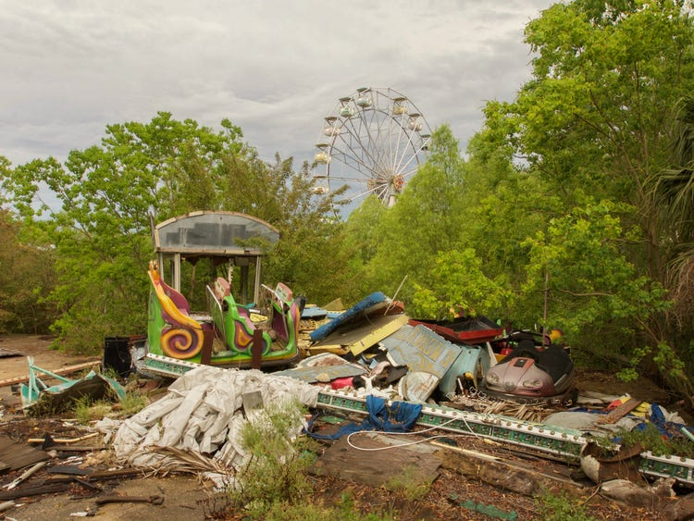

https://www.insider.com/abandoned-amusement-parks-2018-2#once-the-largest-theme-park-in-central-kansas-the-joyland-amusement-park-was-home-to-one-of-the-last-surviving-original-wooden-coasters-12

* + - The maze walls are stone, wood, metal &or plants(bush) (it is multiple because I want a different wall type to represent different parts of the maze & possibly how far you are in the maze). (This is shown in AT02)
    - The maze is mysterious because it seems bigger than what it looked like on the outside.
  + Must establish look and feel of the game.
    - The game will have an eerie feel to it as well as encouraging curiosity.
* Research
  + Similar titles
  + Zardy’s Maze
    - Why use these similarities?
      * It is what helped me decide to do a maze game.
    - What makes your game different?
      * My maze will not be a corn maze but a mix of different styles.

More info for Zardy’s Maze here: <https://store.steampowered.com/app/1484800/Zardys_Maze/>

* + Inspirations (mood boards, screenshots, etc.)
    - Annotate what elements inspired the game design.
      * Six inches under hotbar has inspired my choice in making a hotbar system that is similar.
      * Hotbar reference: <https://www.pcinvasion.com/supraland-six-inches-under-review/>

